**Mapping the Essence of Coffee Quality Insights by Origin with Tableau**

**Problem Statement:**

ABC Company aims to leverage Tableau's visualization capabilities to gain comprehensive insights into the essence of coffee quality across different origins. By mapping flavor profiles across various coffee-producing countries, the company seeks to identify patterns, trends, and potential correlations that can inform strategic decision-making processes. The problem statement revolves around understanding how factors such as processing methods, species, and geographical locations influence flavor attributes in coffee, thereby empowering ABC Company to optimize its sourcing strategies, enhance product offerings, and ultimately elevate customer satisfaction and market competitiveness.



**Prerequisites:**

* Basic understanding of Data Analytics

[What Is Data Analytics? - An Introduction (Full Guide)](https://youtu.be/yZvFH7B6gKI?si=jD37tQzKJH1vl56A)

* Awareness of the lifecycle of a Data Analytics Project

[A Beginners Guide To The Data Analysis Process](https://youtu.be/lgCNTuLBMK4?si=a_J79oNSQIGNuNlH)

* Understand Tableau Interface- [Link](https://www.youtube.com/watch?v=oIw8xJ1Fy3w)
* Download Tableau Desktop-[Link](https://www.tableau.com/products/desktop/download)

**Objective:**

An objective is a specific, measurable, and time-bound goal or target that an individual or organization aims to achieve. Objectives are typically set to guide actions and decision-making towards desired outcomes. They are often a part of broader goals and help to clarify what needs to be accomplished within a certain timeframe. Objectives should be realistic, achievable, and relevant to the overall mission or purpose, providing a clear direction for efforts and resources.

**Task:**

* Explore and analyze the diversity of flavor profiles exhibited by coffee originating from

different countries, aiming to understand the impact of geographical regions on taste attributes such as aroma, acidity, and sweetness.

* Identify and examine any discernible patterns or trends in coffee quality attributes across origins, with a focus on factors such as processing methods, species variations, and harvest years, to facilitate informed decision-making for stakeholders involved in the coffee industry.

**Dataset**: [Link](https://www.kaggle.com/datasets/adampq/coffee-quality-with-locations-of-origin)

**Solution Development Procedure:**

* In Tableau, the "Connect" option refers to the initial step in the data visualization process where users connect to various data sources to import data into Tableau for analysis and visualization.

* When you select the "Connect" option in Tableau, you are presented with a variety of data connection options.

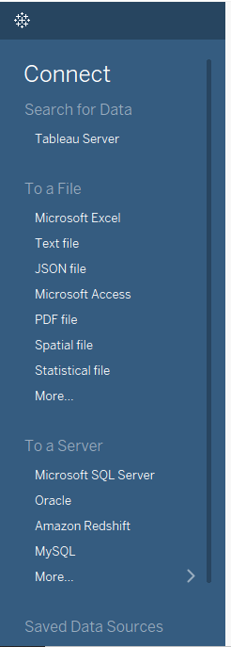 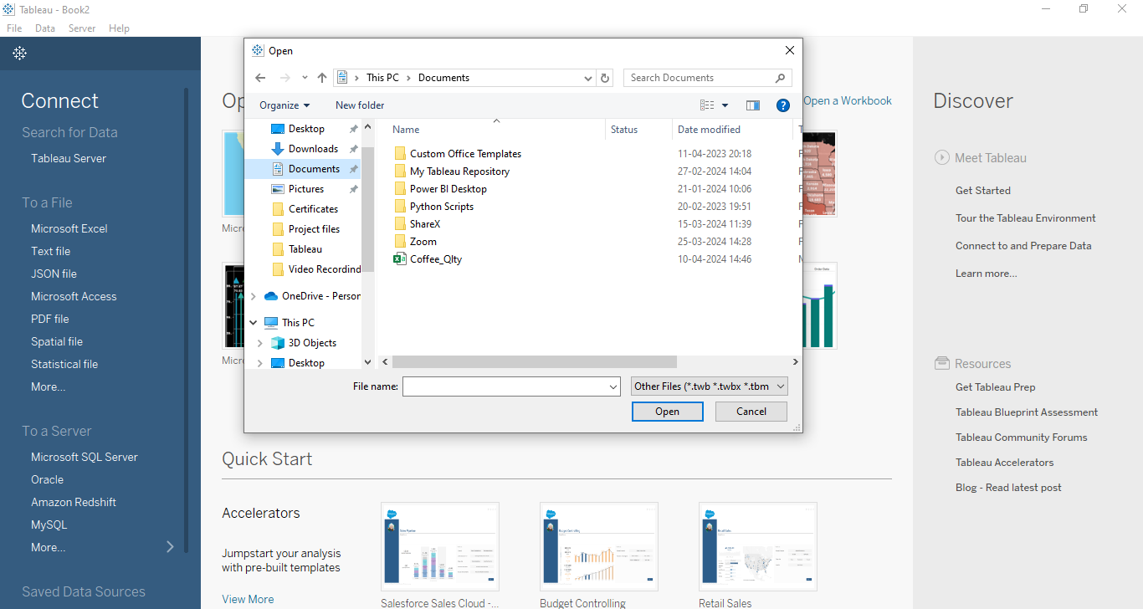

* Once we load the data into the Tableau.

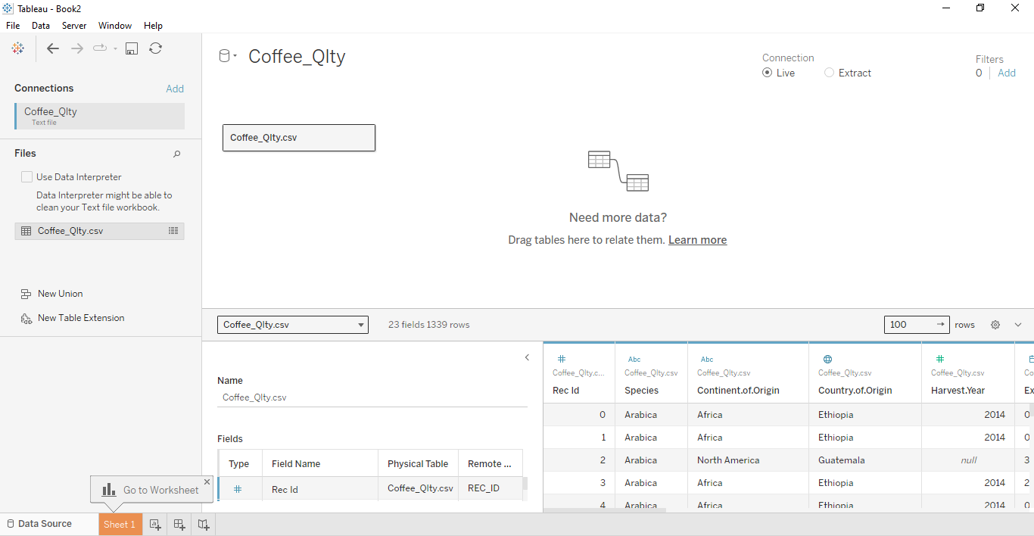

* Select Country and Choose Maps to display in visualization.

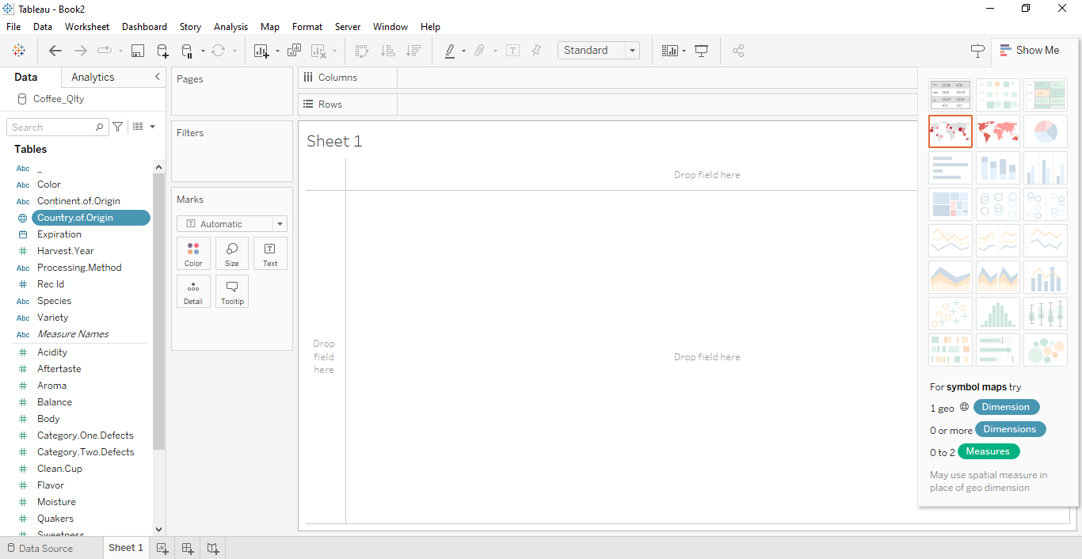

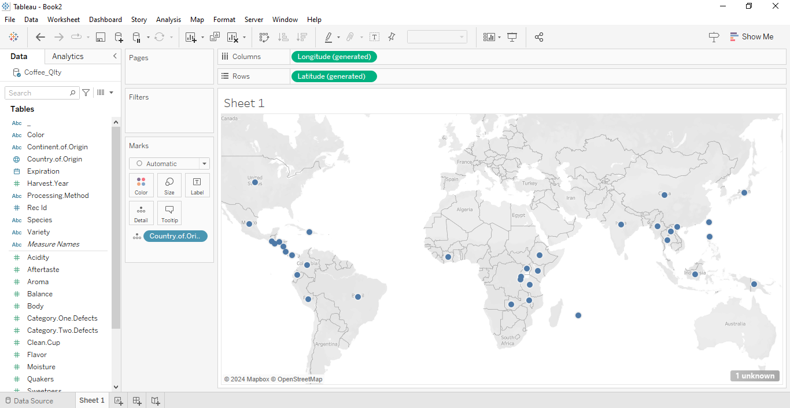

* Select Flavor as numerical measure and display it on your Map visualization.

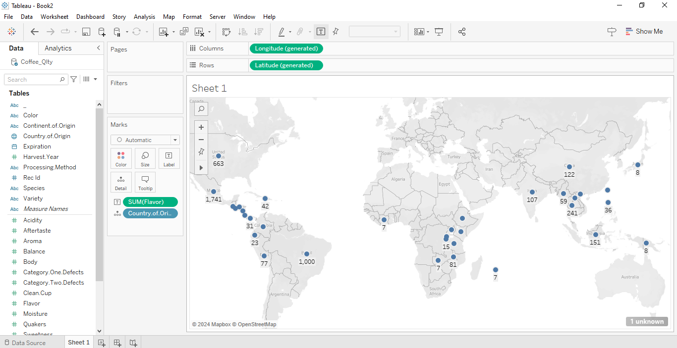

* Select Country of Origin as Filter, Uncheck null and add top 5 countries to display in Map Visualization.

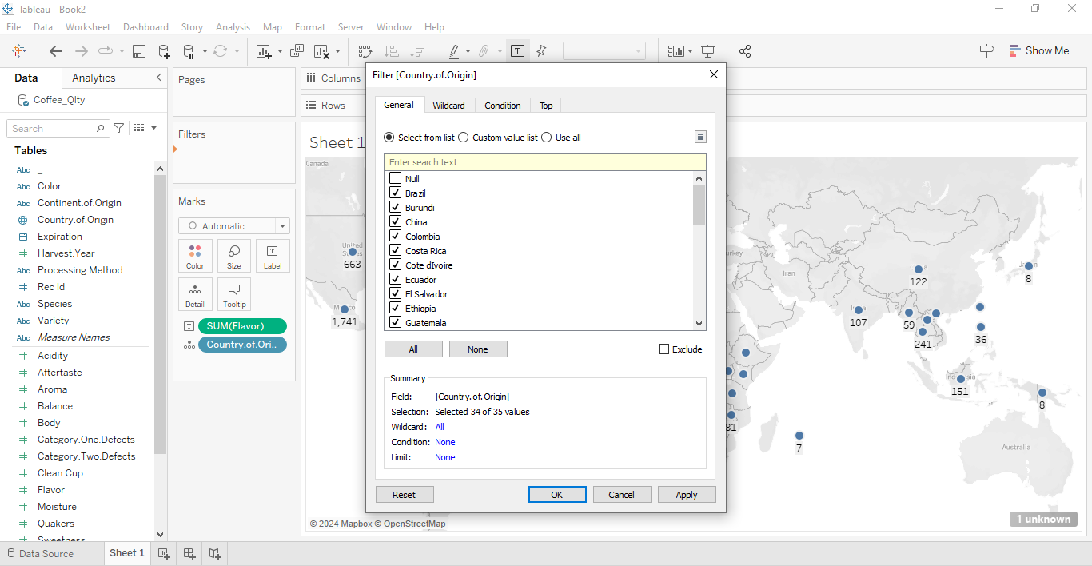

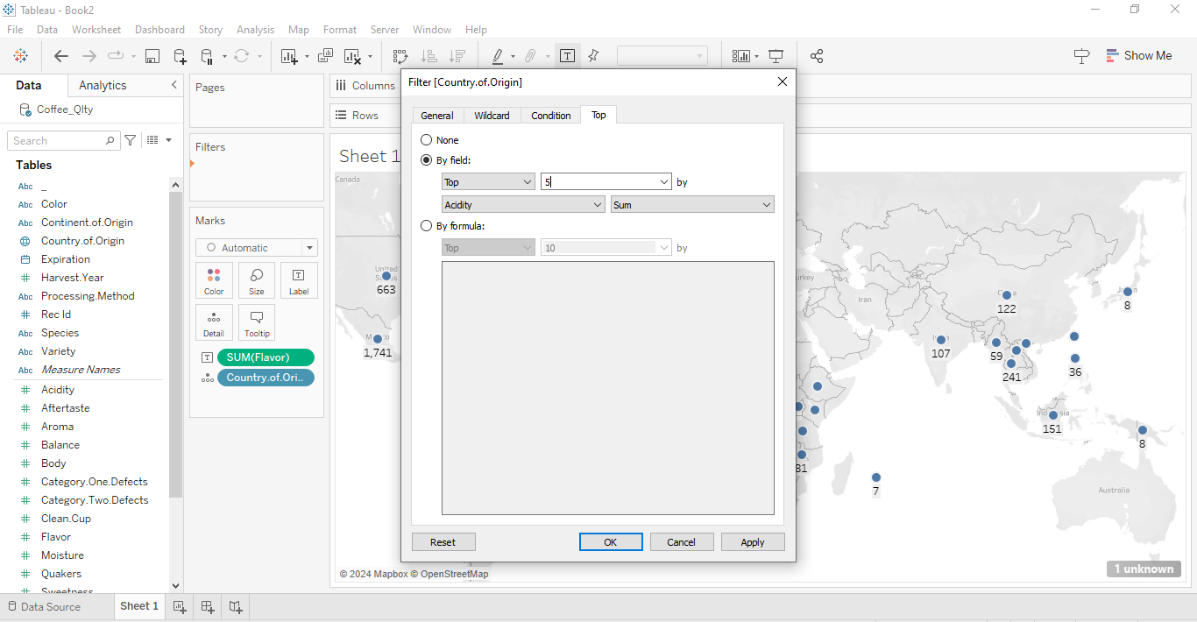

* Choose Background Maps as “Streets”, Add Continent of Region to Colour and Country of Region to label in Marks Card.

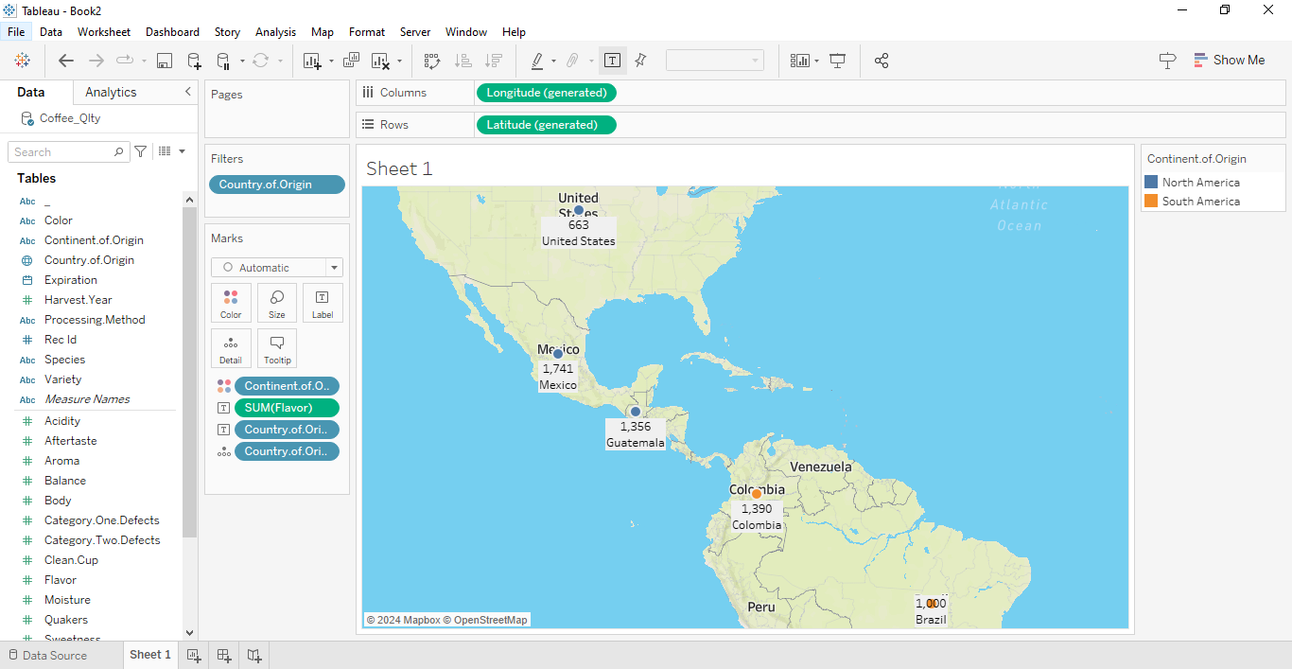

* Choose your Colours and Customize the Title according to Map visualization.

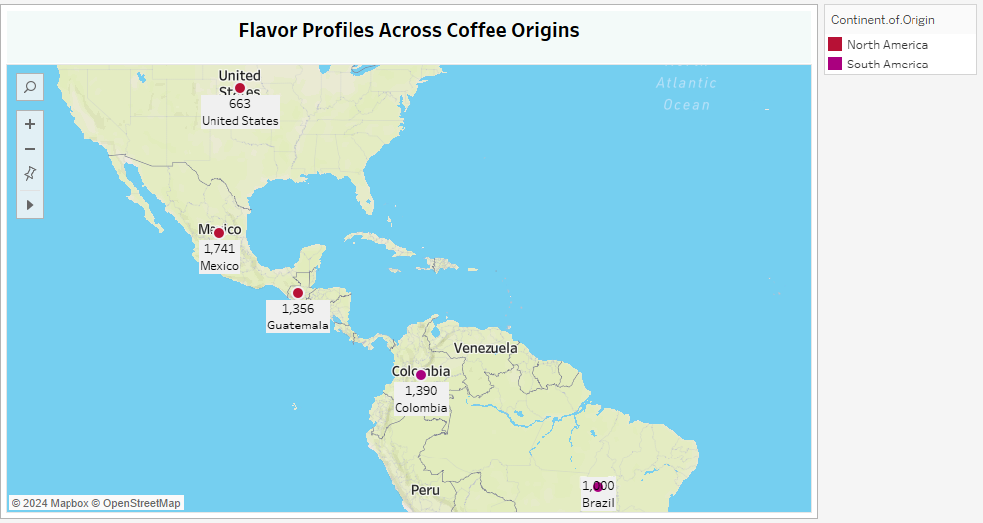

**Insights:**

Insights refer to valuable and meaningful understandings or perceptions gained from analyzing data, information, or experiences. They provide deeper understanding, clarity, or revelation regarding a particular subject or situation.

* Unveil the nuanced taste profiles of coffee from diverse origins, highlighting variations in aroma, acidity, sweetness, and other sensory characteristics unique to each region.
* Identify patterns in coffee quality attributes across origins, offering actionable insights for optimizing sourcing strategies and refining product selection to meet consumer preferences effectively.

**Conclusions :**

Conclusions are logical deductions or decisions drawn from observations, evidence, or analysis. Conclusions are often based on the findings or results of a study, experiment, or evaluation, and they aim to summarize key insights or outcomes. Effective conclusions should be supported by evidence, logical reasoning, and critical thinking, leading to well-informed decisions or actions.

* The analysis underscores the significant impact of geographical origin on coffee flavor, with distinct profiles emerging from different regions worldwide.
* Understanding the diverse flavor profiles enables informed decision-making in sourcing strategies, empowering stakeholders to align their selections with consumer preferences and market demands.
* By leveraging insights into quality trends across origins, companies can refine their product portfolios, ensuring a diverse range of offerings that cater to varying taste preferences and uphold standards of excellence in the coffee industry.